Project Design Phase-II
Data Flow Diagram & User Stories

Date | 9 June 2026
Team ID | 24EG105K42
Project Name | ShopEz
Maximum Marks | 4 Marks

Data Flow Diagrams:
A Data Flow Diagram (DFD) is a traditional visual representation of the information flows within a system. A neat and clear DFD can depict the right amount of the system requirement graphically. It shows how data enters and leaves the system, what changes the information, and where data is stored.
Example: DFD Level 0 (Industry Standard)
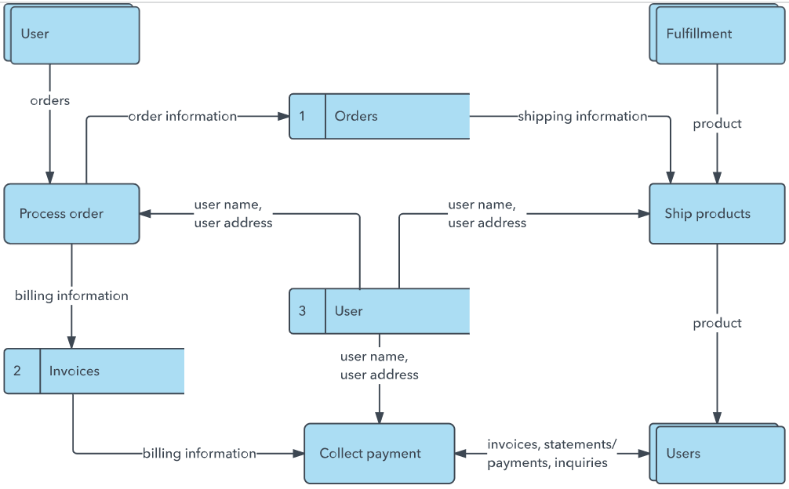
Example: (Simplified)


User Stories
Use the below template to list all the user stories for the product.
User Type | Functional Requirement (Epic) | User Story Number | User Story / Task | Acceptance criteria | Priority | Release
Customer (Web User) | Registration | USN-1 | As a user, I can register using my name, email and password. | User account is created successfully and user can log in. | High | Sprint-1
Customer (Web User) | Login | USN-2 | As a user, I can log in using my registered email and password. | User is redirected to the home page after successful login. | High | Sprint-1
Customer (Web User) | Product Catalog | USN-3 | As a user, I can browse products by category | Products are displayed with image, title and price. | High | Sprint-2
Customer (Web User) | Category Filter | USN-4 | As a user, I can filter products by category. | Only products from the selected category are displayed. | High | Sprint-2
Customer (Web User) | Search Feature | USN-5 | As a user, I can search products using keywords. | Matching products appear instantly. | High | Sprint-2
Customer (Web User) | Cart Management | USN-6 | As a user, I can add products to my shopping cart. | Product is added successfully to cart. | High | Sprint-3
Customer (Web user) | Order Placement | USN-7 | As a user, I can place an order from my cart. | Order details are stored successfully. | High | Sprint-3
Customer Care Executive | Order Placement | USN-8 | As an admin, I can add new products. | Product appears in catalog immediately. | High | Sprint-4
Administrator | Product Management | USN-8 | As an admin, I can edit or delete products. | Changes are reflected successfully. | High | Sprint-4
Administrator | Product Management | USN-9 | As an admin, I can view all customer orders. | Orders are displayed with complete details. | Medium | Sprint-4
Administrator | Product Management | USN-10 | As an admin, I can view all customer orders. | Orders are displayed with complete details. | Medium | Sprint-4

